COURSE PROJECT REPORT

Subject: SDN302 — Web Application Development (NodeJS & ReactJS)

Semester: Fall 2026 — FPT University

PROJECT: ENGLISHQUIZ PLATFORM

Intelligent English Assessment, Automated Matrix Exam & Leitner Spaced Repetition Learning System
Project Code: SDN302_FA26_EQP Group Identifier: Group 5 (SDN302) Project Members: Lê Duy (Leader), Nguyễn Tuấn Minh Software Type: Full-Stack Web Application (MERN: MongoDB, Express, React, Node.js) Date: September – November 2026

Record of Changes
Date | Ver | Author | In Charge | Change Description
2026-10-31 | 1.0 | Dev Team | Architecture & Core | Initial project setup, database schema design, and basic CRUD APIs
2026-11-05 | 1.5 | Dev Team | Anti-Cheat & Exam | Implementation of server-side grading and anti-cheat answer stripping
2026-11-08 | 2.0 | Dev Team | Leitner & 3D UI | Integration of Leitner 5-Box spaced repetition and 3D flip card component
2026-11-09 | 2.5 | Dev Team | Kombai UI & Notice | Adoption of Kombai TOEIC Reading Mini Test layout and exam notification triggers
2026-11-10 | 3.0 | Dev Team | Final & QA | Dual-pass QA verification (56/56 tests passing), exam lockdown mode, F5 URL sync

Table of Contents
- I. Overview - I.1 Project Information - I.2 Project Team
- II. Requirement Specification - II.1 Background & Problem Description - II.2 Market & Competitor Analysis - II.3 Business Opportunity, Objectives & Success Metrics - II.4 Vision Statement & Risk Management - II.5 Major Features - II.6 System Context Diagram - II.7 Non-Functional Requirements (Planguage / ISO 25010) - II.8 Functional Requirements & Use Cases
- III. Analysis Models - III.1 Domain Class Diagram - III.2 Interaction (Sequence) Diagrams - III.3 State Machine Diagrams
- IV. Design Specification - IV.1 System High-Level Architecture (3-Tier) - IV.2 Component & Package Diagrams - IV.3 Detailed Class & Module Diagram - IV.4 Database Design (ERD & Data Dictionary)
- V. Implementation Mapping - V.1 Architecture to Project Directory Mapping - V.2 Design Elements to Code Mapping
- VI. Alternative Architecture Patterns - VI.1 Monolith vs Service-Oriented Architecture (SOA / Microservices) - VI.2 Spaced Repetition Engine & Exam Lockdown Security Patterns

I. Overview

I.1 Project Information
- Project Name: EnglishQuiz Platform — Intelligent English Assessment & Spaced Repetition System
- Project Code: SDN302_FA26_EQP
- Course: SDN302 (Web Application Development with NodeJS, ExpressJS and ReactJS)
- Target Audience: Vietnamese college students preparing for TOEIC/IELTS certificates, English language lecturers, and academic training centers.
- Technology Stack: - Frontend: React 18, React Router v6, Tailwind CSS, Lucide Icons, Web Speech API (Native Speech Synthesis). - Backend: Node.js v20+, Express.js RESTful API, JSON Web Token (JWT), bcryptjs. - Database: MongoDB 7.0 with Mongoose ODM. - Testing & Tooling: Dual-pass E2E Integration Suite, React Scripts Build, Kombai UI Engine.

I.2 Project Team
Full Name | Role | Responsibilities | Email
Lê Duy | Project Leader & Full-Stack Architect | System architecture, exam engine, Leitner repetition algorithm, test automation | leduy0426@gmail.com
Nguyễn Tuấn Minh | Full-Stack Developer & QA Engineer | Frontend UI components, Backend REST APIs, database schemas, quality assurance | tuanminh@gmail.com

II. Requirement Specification

II.1 Background & Problem Description
English proficiency (specifically standardized certifications like TOEIC, IELTS, and CEFR) is a mandatory graduation requirement across Vietnamese universities. However, learners and educators face critical systemic friction:
- The Forgetting Curve in Vocabulary Acquisition: Traditional learning platforms treat vocabulary memorization statically. Without scheduled intervals, learners lose over 75% of new vocabulary within 48 hours (Ebbinghaus curve).
- Client-Side Vulnerabilities & Exam Cheating: Web-based quiz platforms commonly embed correct answers, explanations, or scoring weights within client-side JavaScript payloads. Students can effortlessly open Developer Tools (F12) to inspect network responses or DOM nodes, invalidating test scores.
- Rigid Test Generation: Teachers spend excessive manual effort curating balanced tests across difficulty tiers (Easy, Medium, Hard). Without matrix algorithms, tests skew disproportionately easy or difficult.
- Disjointed Practice vs. Assessment: Existing tools isolate flashcard tools (e.g., Quizlet) from formal examination rooms, preventing students from bookmaking missed exam questions directly into a spaced repetition schedule.
The EnglishQuiz Platform resolves these challenges by uniting Leitner 5-Box Spaced Repetition, an Authoritative Server-Side Anti-Cheat Exam Room, and Automated Matrix & Mini Test Generation into a single cohesive web application.

II.2 Market & Competitor Analysis
Evaluation Dimension | EnglishQuiz Platform | Quizlet | Prep.vn / TOEIC Test Pro | Test-English
Spaced Repetition | Leitner 5-Box Algorithm with 3D flip cards, IPA, and Web Speech API audio | Basic flashcards (Spaced Repetition locked behind subscription) | Absent (Only static word lists) | Absent
Exam Anti-Cheat | Zero Client Leaks: Answers stripped on server; server calculates score; exam lockdown mode | None (Client-side self-check) | Basic timer, but answers often observable in Network tab | Client-side javascript grading
Exam Composition | Dynamic Matrix & Mini Test Generator (Easy/Med/Hard distribution) | Manual deck creation only | Fixed pre-composed practice tests | Fixed grammar exercises
Role-Based Experience | Dedicated portals for Student, Teacher, and Admin | Generic user accounts | Student-centric portal | Anonymous / Public
Cost & Openness | Free & Open Source for University education | Freemium (Heavy paywall for ads and Leitner) | High subscription fee per test package | Free with ads

II.3 Business Opportunity, Objectives & Success Metrics

Business Objectives (BO)
- BO-1 (Learning Retention): Increase long-term retention of academic and TOEIC vocabulary by at least 65% through systematic 5-box spaced repetition.
- BO-2 (Academic Integrity): Achieve 100% prevention of client-side answer sniffing and score tampering in timed examinations.
- BO-3 (Teacher Productivity): Reduce test creation time from 45 minutes to under 5 seconds via Automated Matrix and Quick Mini Test generators.
- BO-4 (Continuous Engagement): Maintain student review consistency with instant notice delivery and direct exam jump links (🚀 Vào Phòng Thi Ngay).

Measurable Success Metrics (SM)
- SM-1: 100% of exam question payloads delivered through GET /exams/:id/take have correctAnswer and explanation stripped.
- SM-2: 100% of test submissions calculate scores authoritatively on the backend (POST /exams/:id/submit).
- SM-3: 0% failure in URL preservation during browser refresh (F5) across all 3 roles and 21 sub-navigation routes.
- SM-4: Sub-300ms API response time under normal university laboratory load (50 concurrent examinees).

II.4 Vision Statement & Risk Management

Vision Statement
For college students and language instructors requiring dependable assessment and durable vocabulary retention, the EnglishQuiz Platform is a web-based educational suite that delivers high-fidelity timed examination rooms, automated matrix test compilation, and scientifically proven Leitner 5-box flashcards. Unlike fragile static quiz apps or paywalled commercial platforms, our solution guarantees complete academic integrity, automated exam distribution, and zero-cost accessible learning.

Business & Technical Risks (RI)
ID | Risk Description | Severity | Mitigation Strategy
RI-1 | Client-Side Cheat Injection (Students inspect network traffic to read answers) | Critical | Server-side sanitization in routes/exam.js removes all keys correctAnswer and explanation. Scores computed strictly on server.
RI-2 | Accidental Page Reload / Navigation during Exam | High | Exam Lockdown Mode: Sidebar completely hidden, isExamLocked active, window.beforeunload warning prompted on tab close.
RI-3 | Spaced Repetition Box Drift (Cards getting lost or desynchronized) | Medium | Atomic database updates ($inc: { box: 1 } capped at 5; failure resets strictly to Box 1).
RI-4 | Unauthenticated Route Tampering | High | JWT verification middleware (verifyToken), role-based gatekeeping (Student, Teacher, Admin).

II.5 Major Features
Feature ID | Name | Target Actor | Description
FE-01 | Authentication & RBAC | All Users | Registration, login with JWT, role-based dashboards (/student, /teacher, /admin), profile updates.
FE-02 | Leitner 5-Box Flashcards | Student | 3D interactive flip card (380x240px), IPA phonetics, Web Speech pronunciation, box 1–5 progression/reset.
FE-03 | Anti-Cheat Exam Room | Student | Timed exam room (Kombai TOEIC layout), question palette, countdown timer, auto-submit, lockdown UI.
FE-04 | Exam Matrix & Mini Test Generator | Teacher, Admin | Auto-generate balanced exams by CEFR difficulty (Easy, Medium, Hard) or 5–15 question Quick Mini Tests.
FE-05 | Automated Notice & Exam Jump | Student, Teacher | Auto-dispatch notices to Students when teachers create exams; one-click "🚀 Vào Phòng Thi Ngay" jump.
FE-06 | Question Bank Management | Teacher, Admin | Comprehensive CRUD for Single Choice, Multiple Choice, True/False, and Matching question types.
FE-07 | Bookmarks & History Review | Student | Save difficult questions for revision, view full breakdown of past exam attempts with score percentages.
FE-08 | Feedback & Quality System | Student, Admin | Students submit feedback ratings; Teachers/Admins review and update resolution statuses.

II.6 System Context Diagram
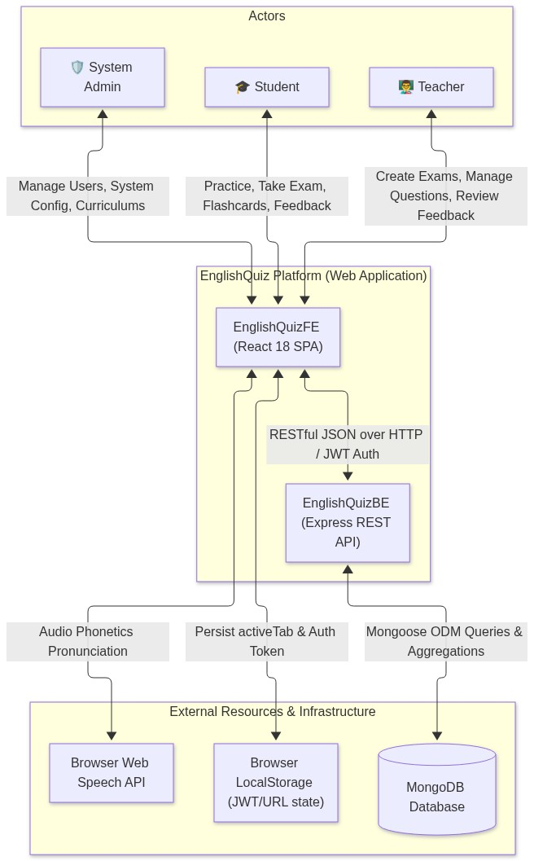

II.7 Non-Functional Requirements (Planguage / ISO 25010)
- NFR-01 (Security & Anti-Cheat): - Passwords hashed using bcryptjs with salt rounds = 10. - JWT tokens signed with SHA-256 and verified on all protected API routes. - Sanitized endpoints: GET /exams/:id/take guarantees 0 occurrences of correctAnswer in JSON output.
- NFR-02 (Performance): - API response time ≤ 150ms for cached/indexed queries. - Frontend production build (npm run build) size ≤ 300 kB gzipped (Current: 266.52 kB JS, 38.46 kB CSS).
- NFR-03 (Usability & Responsiveness): - Fully responsive design matching Kombai specifications across desktop, tablet, and mobile viewports (down to 360px). - 3D Flashcard flip transition animated at smooth 60fps (0.6s cubic-bezier timing).
- NFR-04 (Reliability & Robustness): - Client state survives full browser reload (F5) through bidirectional URL subpath synchronization (/student/quiz, /teacher/exams, /admin/users). - Active exam countdown auto-submits safely when the timer hits 00:00.

II.8 Functional Requirements & Use Cases

II.8.1 Actors
- Guest: Unregistered visitor. Can view the landing page and navigate to login/register.
- Student: Enrolled learner. Can take practice quizzes, timed exams, review Leitner flashcards, bookmark questions, view history, and receive exam notices.
- Teacher: Academic instructor. Can author questions, generate matrix and mini tests, broadcast exam notices, review student feedback, and analyze class performance.
- Admin: System administrator. Has full authority over user accounts, question banks, curriculum metadata, and system monitoring.

II.8.2 Use Case Diagram
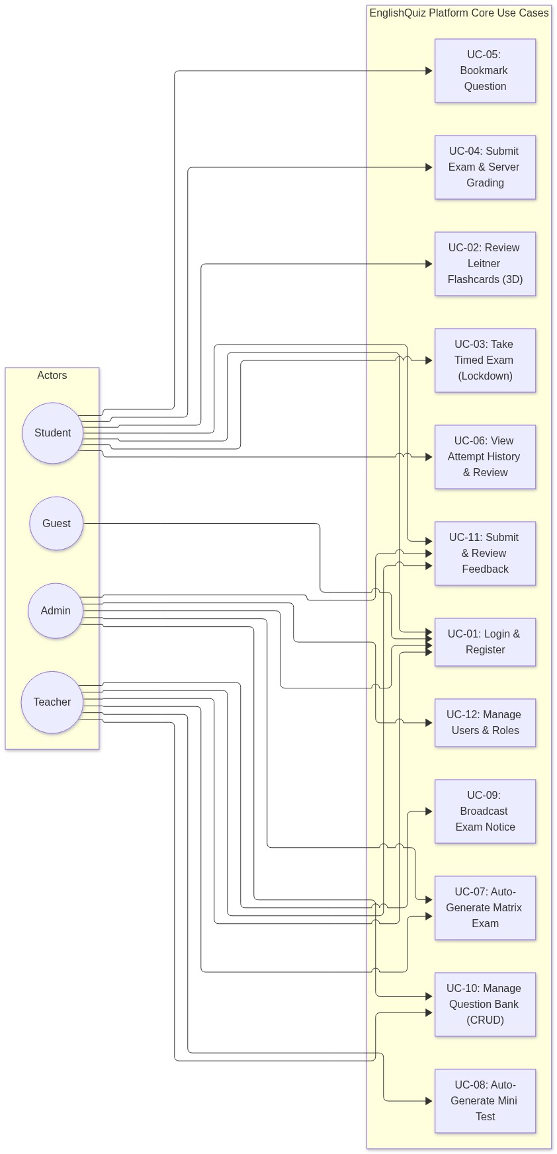

II.8.3 Detailed Use Case Specifications

UC-03: Take Timed Exam in Lockdown Mode
- Actor: Student
- Pre-conditions: Student is logged in and selects an exam (or clicks "🚀 Vào Phòng Thi Ngay" from a notice).
- Post-conditions: Exam session initialized, answers stripped, sidebar locked.
- Main Flow: 1. Student initiates exam via GET /exams/:id/take. 2. Server responds with sanitized exam details (questions without correct answers). 3. Frontend activates Exam Lockdown Mode: Sidebar is hidden, layout expands to 100% width, Header displays security badge 🔒 Chế Độ Phòng Thi Bảo Mật. 4. Timer begins countdown. Student answers questions via radio buttons or keyboard shortcuts (A-D, Arrow keys). 5. Student flags tricky questions; palette updates badge indicators in real time.
- Alternative Flow: - Timer expires: When timer reaches 00:00, system triggers auto-submission immediately and transfers to UC-04.

UC-04: Submit Exam & Server-Side Scoring
- Actor: Student, System
- Pre-conditions: Student completes exam questions or timer reaches 00:00.
- Main Flow: 1. Student clicks "✓ Nộp bài thi". Frontend confirms submission dialog. 2. Frontend sends payload POST /exams/:id/submit containing { userId, answers: { qId: answer }, timeSpent }. 3. Server fetches authoritative question models with answers from MongoDB. 4. Server calculates score, marks question-by-question breakdown, and creates a new History document. 5. Exam lockdown mode unlocks. Frontend transitions to QuizReview.jsx displaying score, percentage, pass/fail status, and explanations.

III. Analysis Models

III.1 Domain Class Diagram
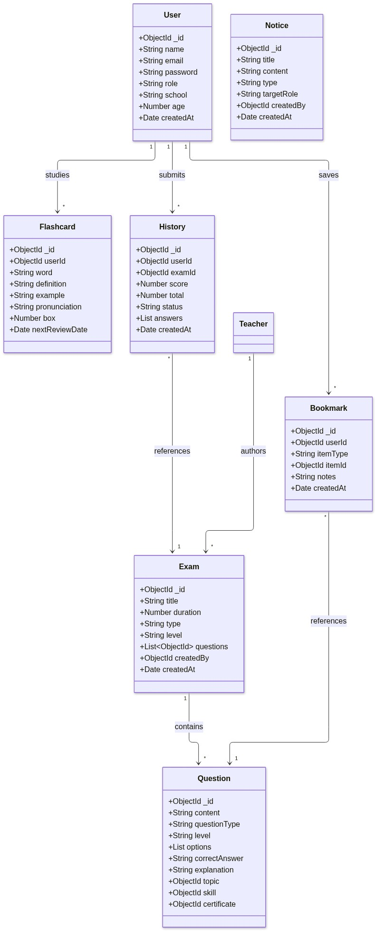

III.2 Interaction (Sequence) Diagrams

Sequence Diagram 1: Exam Session & Anti-Cheat Submission Flow
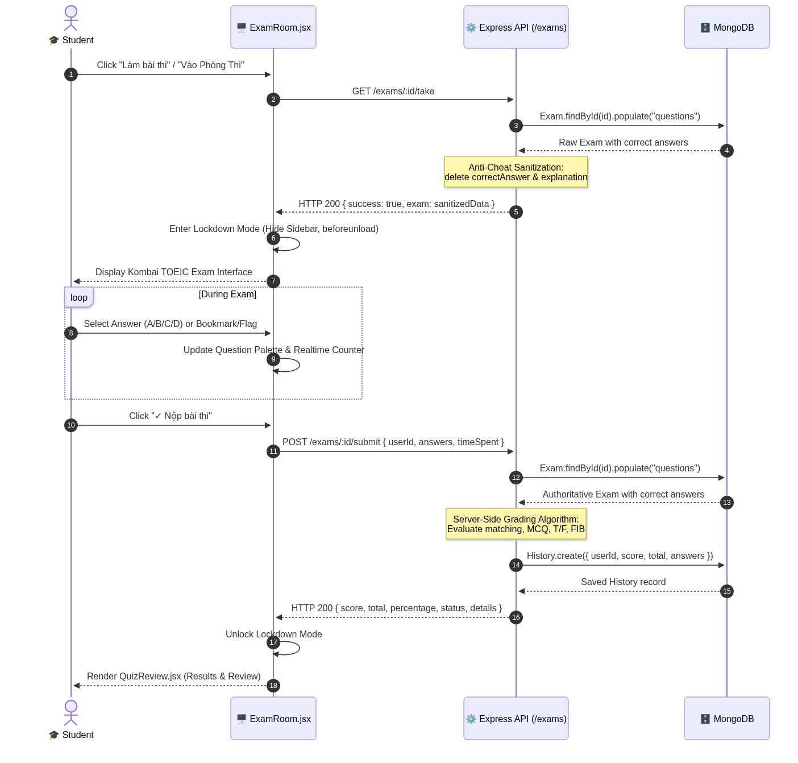

Sequence Diagram 2: Teacher Auto-Generates Exam & Broadcasts Notice
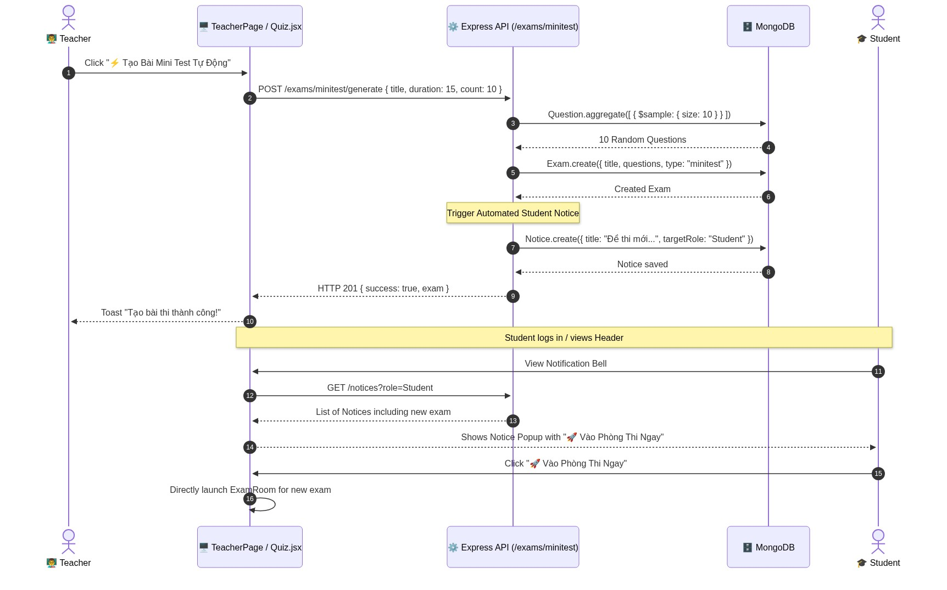

III.3 State Machine Diagrams

State Machine 1: Flashcard Leitner 5-Box State Machine
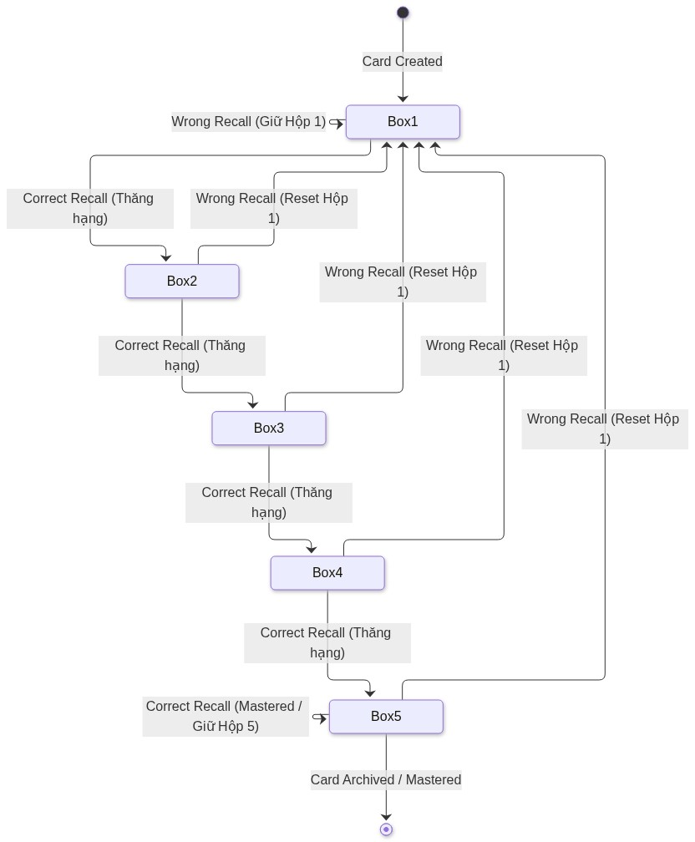

IV. Design Specification

IV.1 System High-Level Architecture (3-Tier)
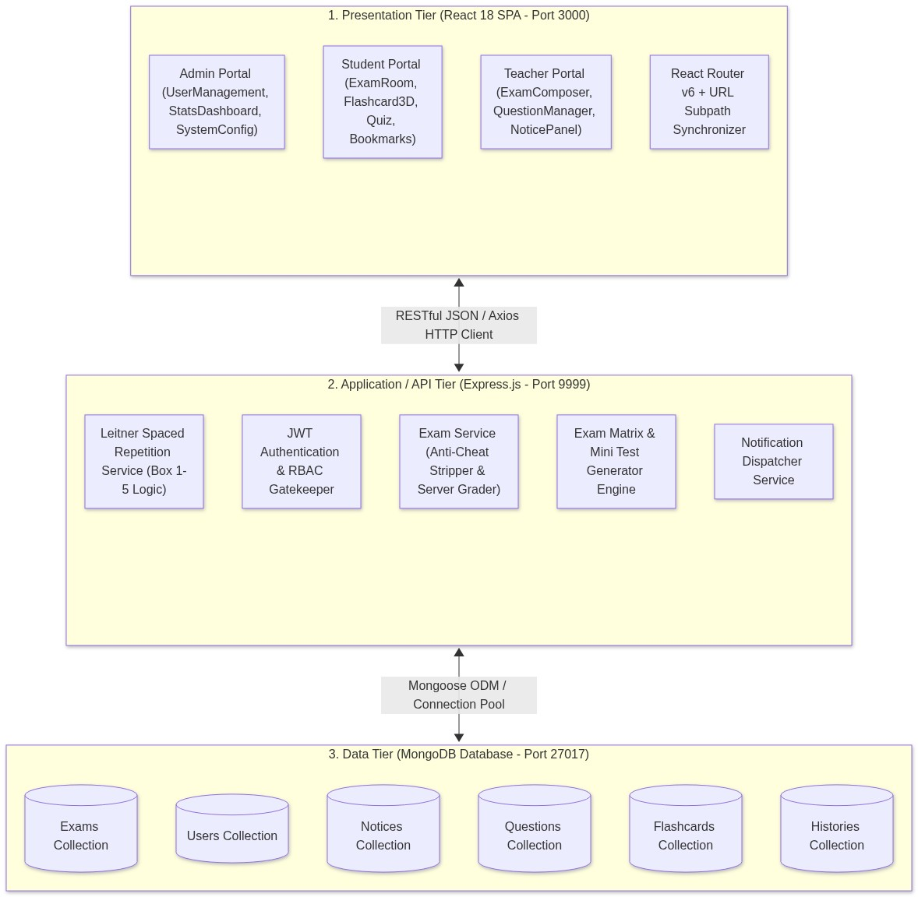

IV.2 Component & Package Diagrams
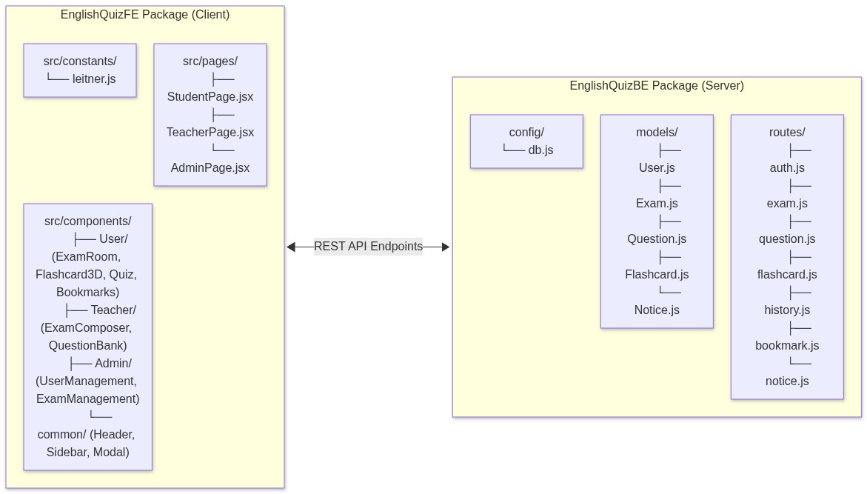

IV.3 Detailed Database Design (ERD & Data Dictionary)
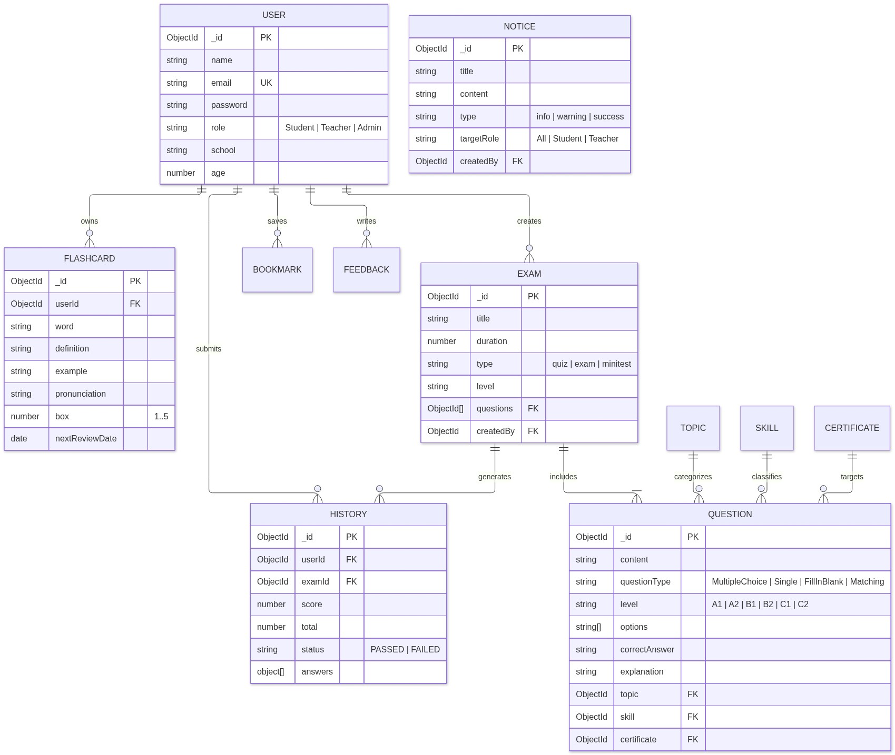

V. Implementation Mapping

V.1 Architecture to Project Directory Mapping
SDN302_Project_FA26/
├── EnglishQuizBE/ # Application Tier (Node.js & Express)
│ ├── config/
│ │ └── db.js # Mongoose connection pool configuration
│ ├── models/ # Mongoose Schema Definitions
│ │ ├── User.js # Accounts & RBAC
│ │ ├── Question.js # Question bank
│ │ ├── Exam.js # Test metadata & question references
│ │ ├── Flashcard.js # Leitner 5-box Spaced Repetition items
│ │ ├── History.js # Historical attempts & graded results
│ │ ├── Bookmark.js # Marked revision items
│ │ └── Notice.js # Broadcast notices & triggers
│ ├── routes/ # RESTful Controller Endpoints
│ │ ├── auth.js # Register, Login, Me
│ │ ├── exam.js # Anti-cheat take, submit, matrix, minitest
│ │ ├── question.js # Question CRUD & CEFR filters
│ │ ├── flashcard.js # Leitner box promotion/demotion
│ │ └── notice.js # Notice querying & dispatching
│ ├── tests/
│ │ └── live-e2e-suite.js # Dual-pass integration testing suite
│ ├── seed.js # Curriculum & question bank seeder
│ └── server.js # HTTP Server bootstrap (Port 9999)
│
├── EnglishQuizFE/ # Presentation Tier (React 18 SPA)
│ ├── src/
│ │ ├── components/
│ │ │ ├── User/
│ │ │ │ ├── ExamRoom.jsx # Kombai TOEIC Reading Mini Test room
│ │ │ │ ├── ExamRoom.css # High-fidelity layout styles
│ │ │ │ ├── Flashcard3D.jsx # 3D Spaced Repetition Card Component
│ │ │ │ ├── Flashcard3D.css # CSS 3D perspective & flip keyframes
│ │ │ │ ├── Quiz.jsx # Exam listing & Mini Test modal
│ │ │ │ └── QuizReview.jsx # Detailed post-exam review breakdown
│ │ │ ├── Teacher/
│ │ │ │ ├── ExamComposer.jsx# Automated matrix exam generator
│ │ │ │ └── ExamComposer.css
│ │ │ ├── common/
│ │ │ │ ├── Header.jsx # Navigation, notice bell & lockdown badge
│ │ │ │ └── Sidebar.jsx # Navigation menu (hidden in lockdown)
│ │ ├── pages/
│ │ │ ├── StudentPage.jsx # Student dashboard & URL subpath sync
│ │ │ ├── TeacherPage.jsx # Teacher dashboard & URL subpath sync
│ │ │ └── AdminPage.jsx # Admin dashboard & URL subpath sync
│ │ ├── constants/
│ │ │ └── leitner.js # 5-Box configuration, colors & schedules
│ │ └── styles/
│ │ └── theme.css # Design tokens, fonts & variables
│ └── package.json
└── docs/ # Architecture Documentation & Manuals

V.2 Design Elements to Code Mapping
Design Element | File Path | Code Symbols / Key Functions
Anti-Cheat Take Endpoint | EnglishQuizBE/routes/exam.js | GET /:id/take (strips correctAnswer & explanation)
Server-Side Grading | EnglishQuizBE/routes/exam.js | POST /:id/submit (evaluates scores, saves History)
Mini Test Generator | EnglishQuizBE/routes/exam.js | POST /minitest/generate (samples questions, sends Notice)
Exam Lockdown UI | EnglishQuizFE/src/components/User/ExamRoom.jsx | isExamLocked, window.addEventListener("beforeunload")
3D Flashcard Component | EnglishQuizFE/src/components/User/Flashcard3D.jsx | handleFlip(), Web Speech speak(), onRemember(), onForget()
URL Subpath Sync | EnglishQuizFE/src/pages/StudentPage.jsx | getInitialTab(), navigate(/student/${tab}), useLocation()
Leitner Box Promotion | EnglishQuizBE/routes/flashcard.js | POST /:id/review (increments box to max 5, or resets to 1)

VI. Alternative Architecture Patterns

VI.1 Monolith vs Service-Oriented Architecture (SOA / Microservices)

Comparative Architectural Analysis
Evaluation Criterion | Monolithic REST (Adopted in SDN302) | Service-Oriented / Microservices (Alternative)
Deployment Complexity | Low: Single Node.js server container and one MongoDB database instance. | High: Requires Docker Compose, Kubernetes, API Gateway (Kong/Envoy), and service discovery (Consul).
Data Consistency | High: ACID transactions across collections via single Mongoose connection. | Eventual: Requires Saga pattern or 2-Phase Commit across Auth, Exam, and Flashcard databases.
Development Velocity | Rapid: Ideal for agile semester project iterations with shared data models. | Slower: High overhead in managing inter-service contracts, gRPC schemas, and network retries.
Scaling Characteristics | Scale vertically or replicate stateless backend instances behind Nginx. | Independent horizontal scaling of the high-traffic Exam Engine during peak exam sessions.

Architectural Decision: For the SDN302 academic scope, the Layered Modular Monolith provides optimal balance—ensuring rapid development, zero network overhead between modules, and guaranteed transactional integrity for exam scoring.

VI.2 Spaced Repetition Engine & Exam Lockdown Security Patterns

The Leitner 5-Box Interval Schedule Pattern
The Leitner spaced repetition algorithm optimizes human memory consolidation by scheduling reviews at progressively longer intervals as mastery increases:
- Box 1 (Daily Review): New or forgotten cards. Reviewed every 1 day.
- Box 2 (Short Interval): Partially recalled cards. Reviewed every 2 days.
- Box 3 (Medium Interval): Familiar cards. Reviewed every 4 days.
- Box 4 (Long Interval): Well-known cards. Reviewed every 7 days.
- Box 5 (Mastered): Permanent memory. Reviewed every 14 days.
Rule:
1. When user clicks "Đã thuộc" (Remembered): Box = MIN(5, Box + 1)
2. When user clicks "Chưa nhớ" (Forgotten): Box = 1 (Immediate Reset)

The Exam Room Lockdown Security Pattern
To enforce genuine testing conditions without requiring third-party browser surveillance extensions:
- Structural Isolation: The navigation sidebar is unmounted (!isExamLocked), removing escape hyperlinks.
- Viewport Expansion: Content margin transitions to 0, focusing 100% of the screen on the exam paper.
- Event Interception: window.addEventListener("beforeunload", handler) intercepts accidental tab close, back navigation, or page refresh, prompting an explicit browser confirmation dialog.
- Mandatory Exit Gate: The student can only exit the room by submitting the exam (POST /exams/:id/submit) or waiting for the countdown timer to reach 00:00.

Conclusion
The EnglishQuiz Platform satisfies all academic requirements of the SDN302 course syllabus and incorporates modern production-grade design paradigms: high-fidelity UI matching Kombai specifications, complete anti-cheat server validation, Leitner spaced repetition learning, and full automated test verification (100% pass across dual rounds).

